Lab Report

Your Information
Your Name: Joshua Zimmerman-Gibson
Assignment Title: MongoDB Data Handling

Screenshots
- Insert a new document into the Sales Collection. Set the satisfaction to -1 and the email to your ECPI email address.
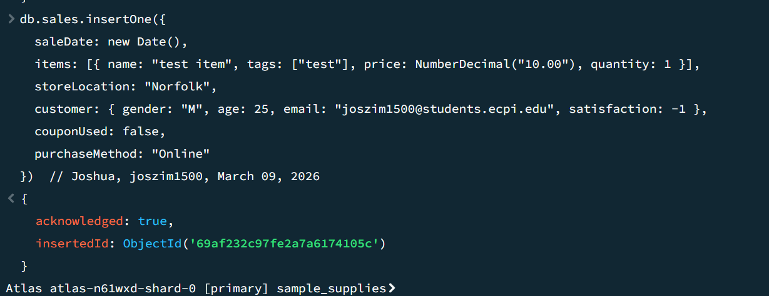
- Display the top 5 products purchased with a price over $50. Only show the name, tags, and price.
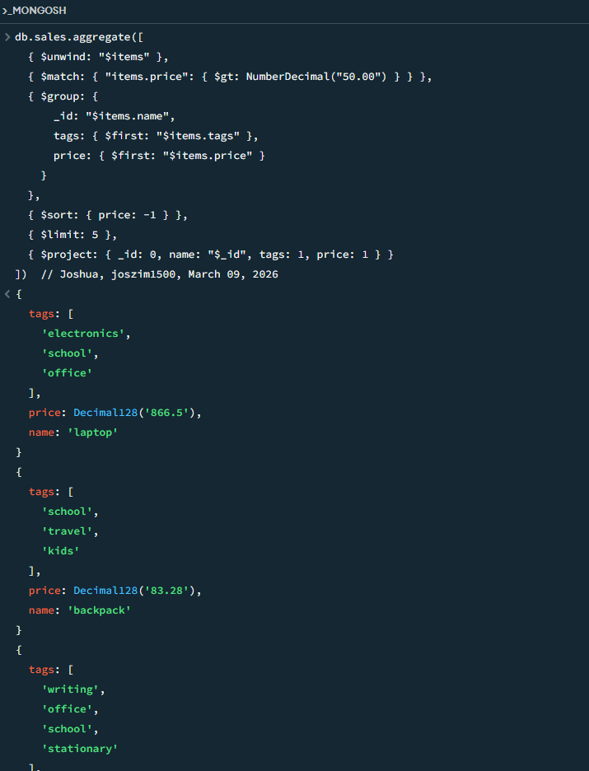
- Display the store location, name, and price of envelopes that were purchased for under $20. Limit the results to 10.
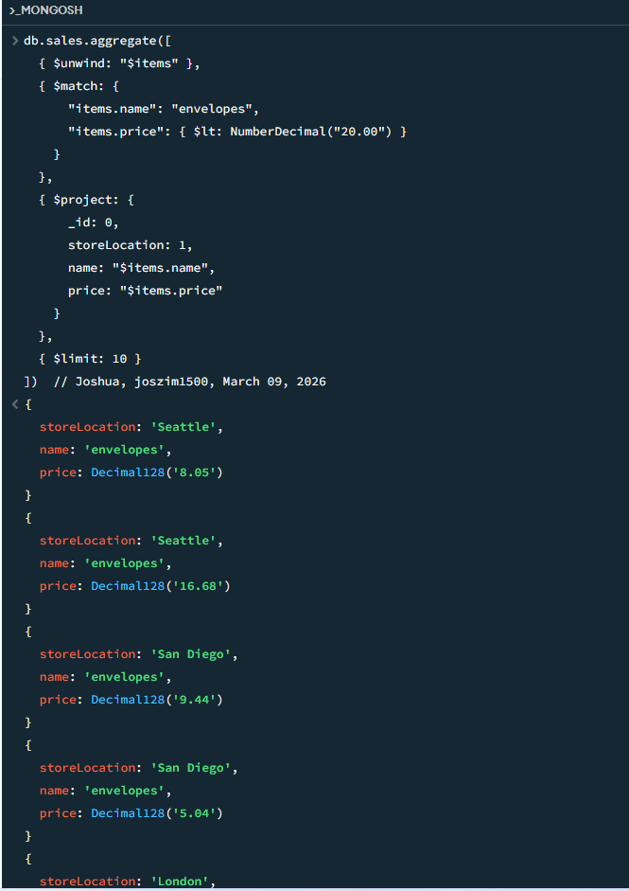
- Display the In store sales in London made by customers younger than 30 who used a coupon.
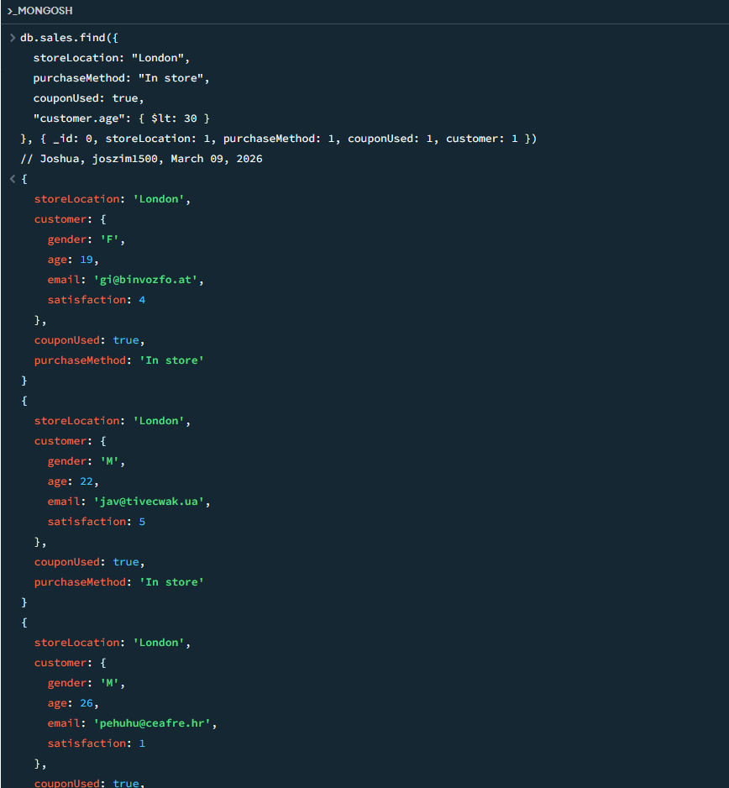
- Delete any orders with a satisfaction of less than 0.
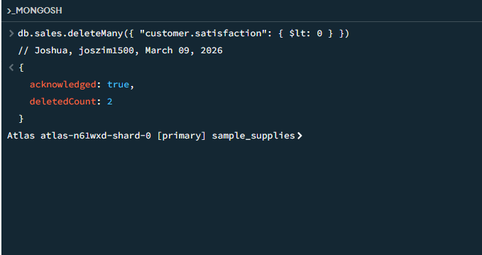
- For all Online orders where a coupon was used, update the price of all items to have a 15% discount.
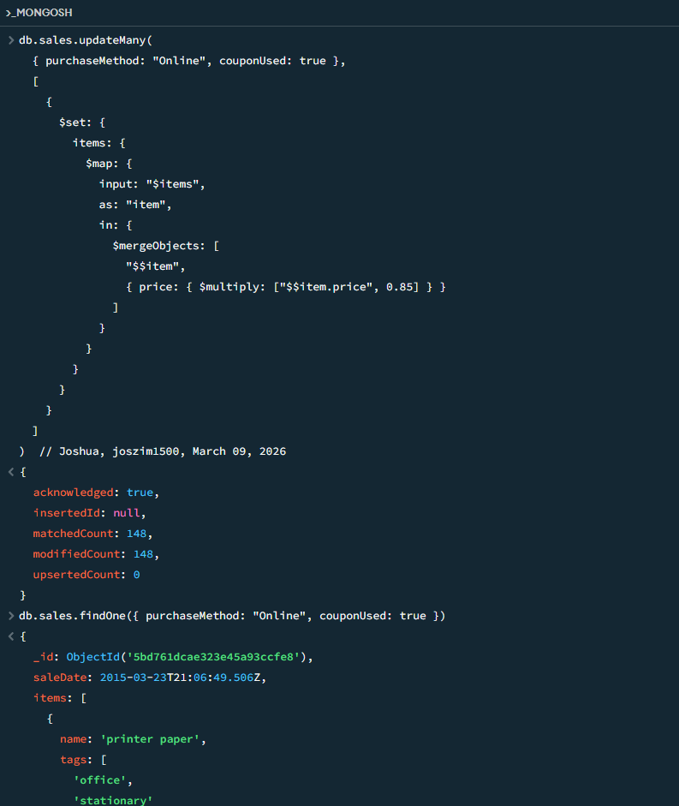
- Find all purchases made with a ".mk" email account using a text indexing search.
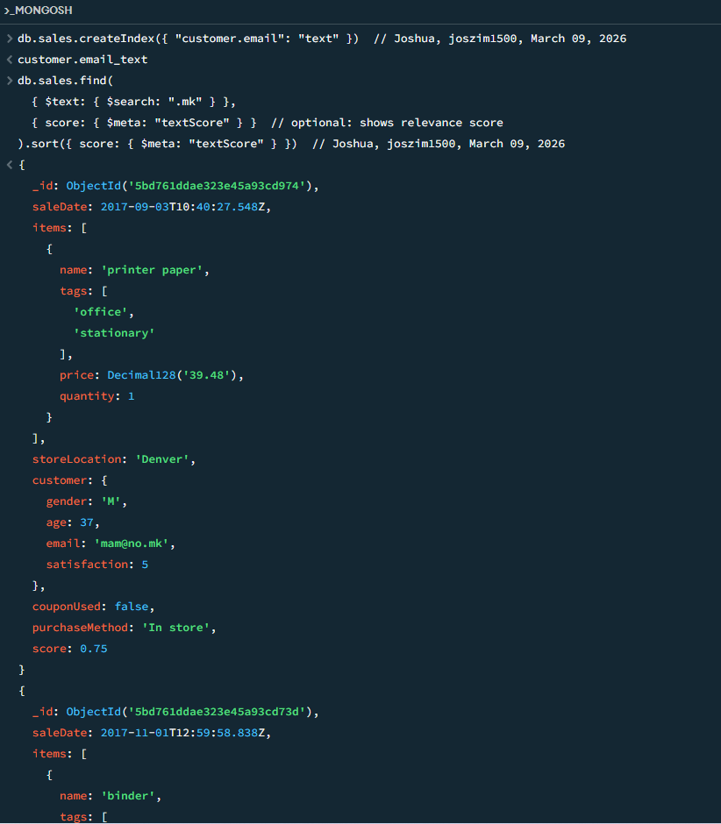
- Perform the following indexing and geospatial queries - all coordinates are in the format Longitude, Latitude. (NOTE: Include screenshots for each of the 10 steps below.):
  - Update all Austin stores. Add a new field array named "coordinates" and set its values to: 97.7431, 30.2672.
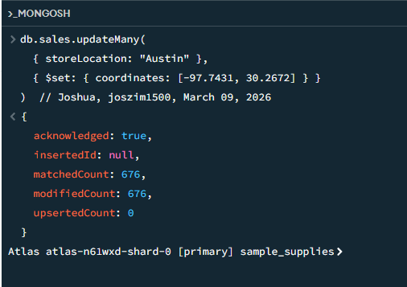
  - Update all Denver stores. Add a new field array named "coordinates" and set its values to: 104.9903, 39.7392.
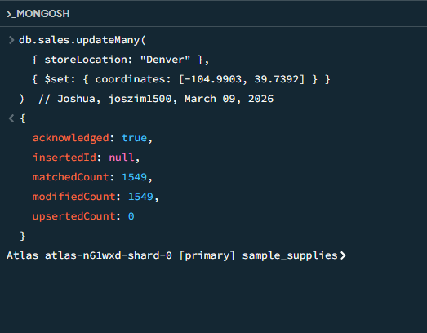
  - Update all London stores. Add a new field array named "coordinates" and set its values to: 0.1276, 51.5072.
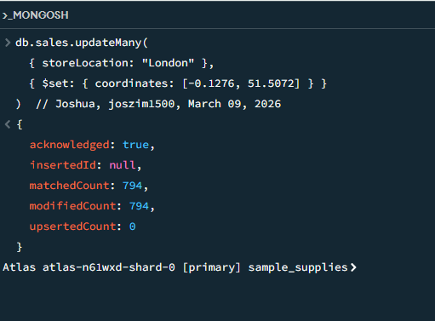
  - Update all New York stores. Add a new field array named "coordinates" and set its values to: 74.0060, 40.7128.
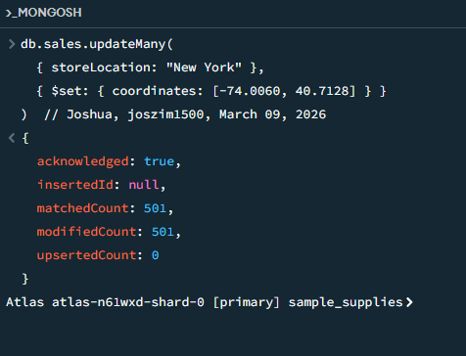
  - Update all San Diego stores. Add a new field array named "coordinates" and set its values to: 117.1611, 32.7157.
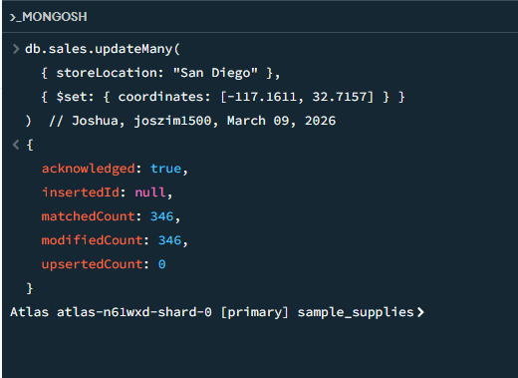
  - Update all Seattle stores. Add a new field array named "coordinates" and set its values to: 122.3328, 47.6061.
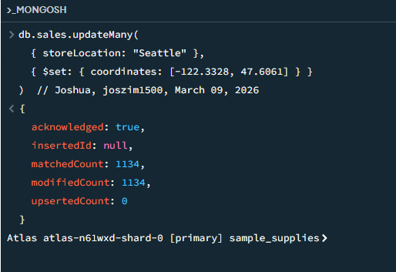
  - Create a 2dsphere index around coordinates.
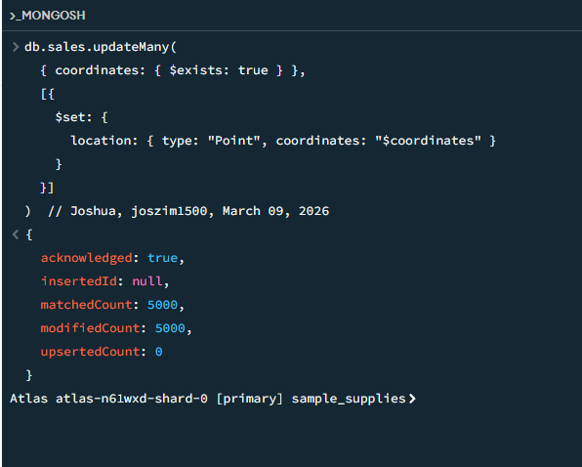
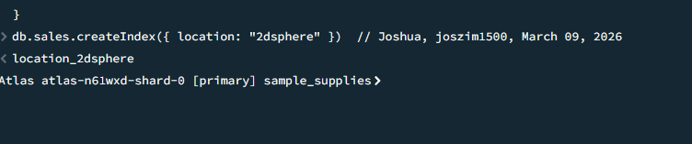
  - Find all stores within 3000000 meters of the coordinate point 75.9792, 36.8516.
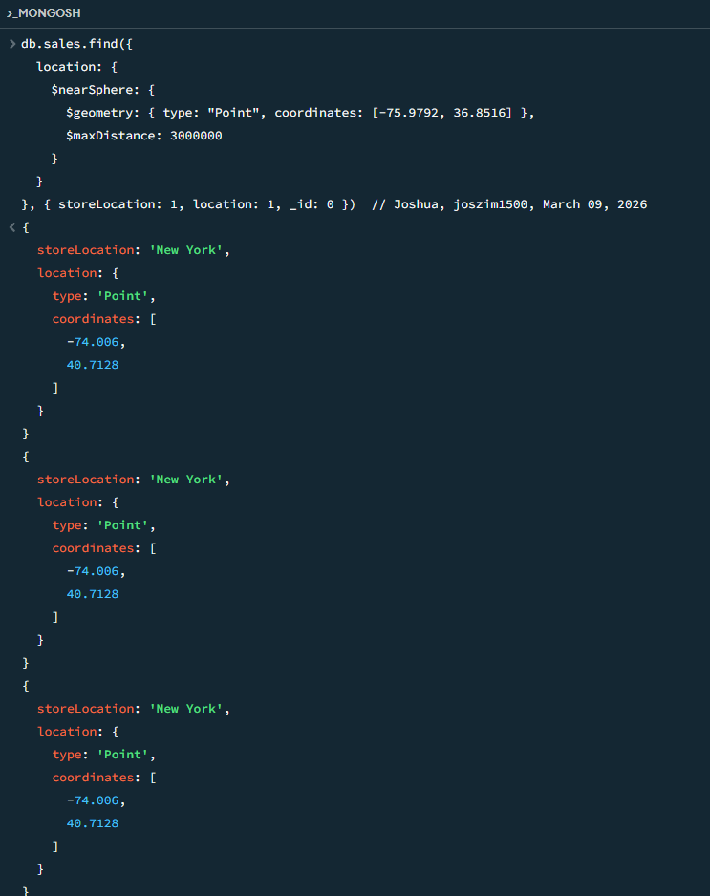
  - Find all stores within 275000 meters of the coordinate point 78.6382, 35.7796.
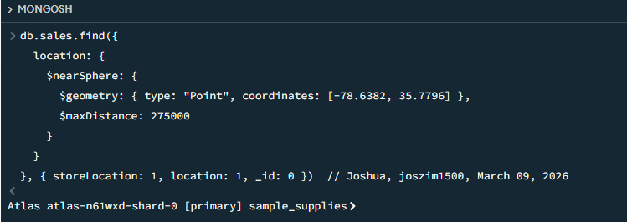
  - Find all stores within 150000 meters of the coordinate point 98.4946, 29.4252.
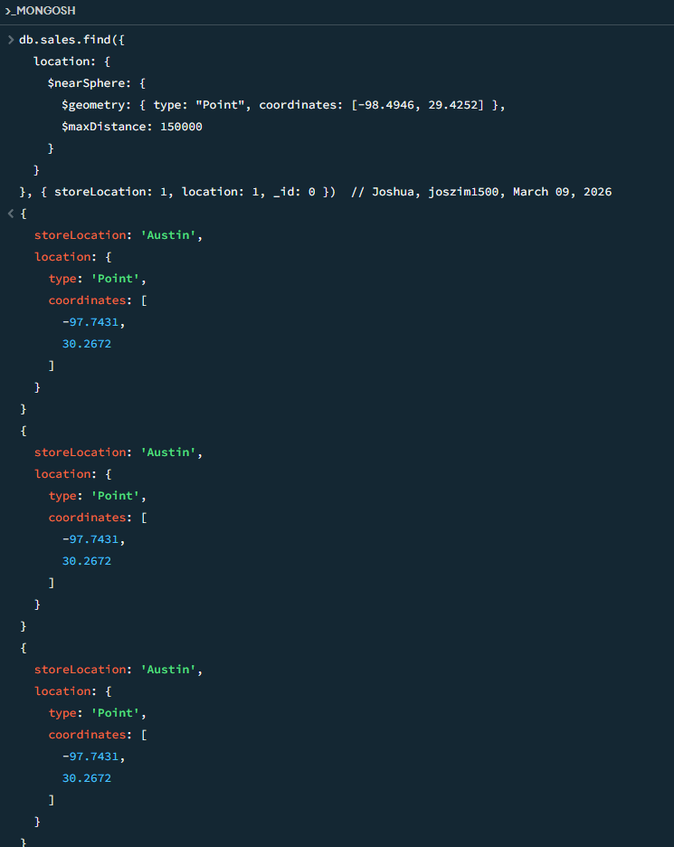
- Perform the following queries including aggregations and sorting (NOTE: Include screenshots for each of the four (4) steps below):
  - Find the highest- and lowest-priced items purchased at each store location.
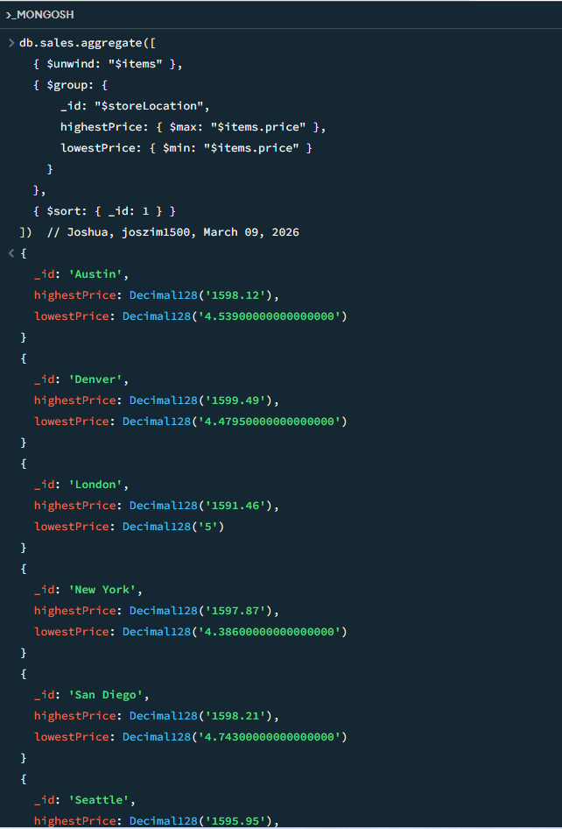
  - Count the number of sales based on purchase method and store location. Sort the results in alphabetical order of store location.
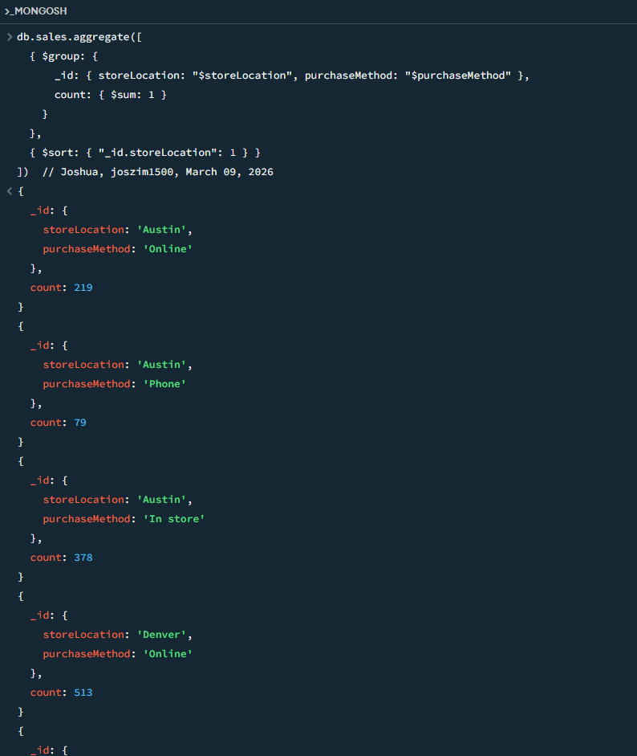
  - Find the average of total money spent per sale per purchase method. Sort the results in descending order of average.
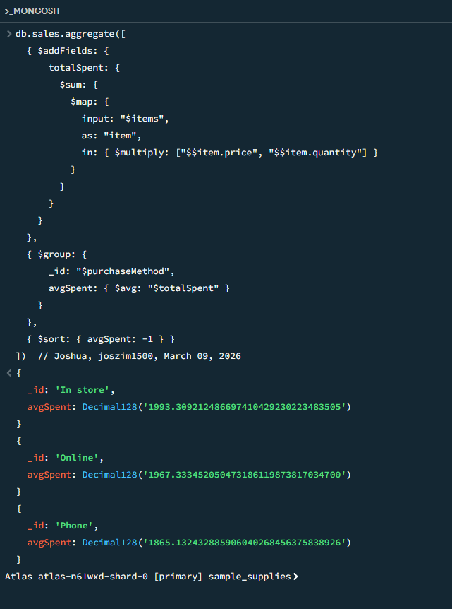
  - Find the average of total money spent per sale per store location. Sort the result in ascending order of average.
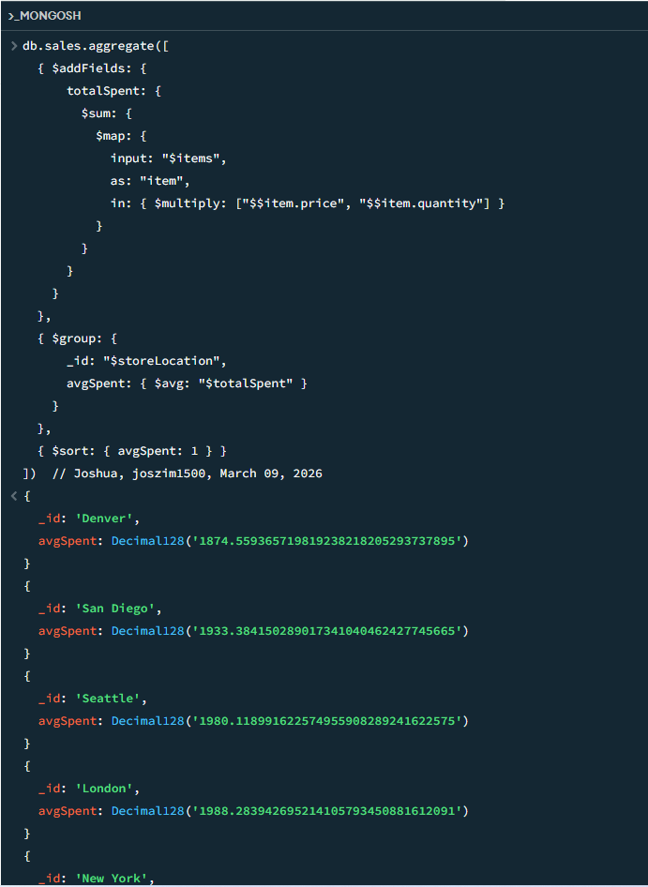
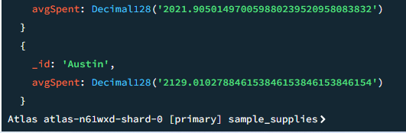

Questions
- How does MongoDB's document database handle scalability, especially in terms of both horizontal and vertical scaling?
MongoDB handles scalability very well because it gives you two main ways to grow as your app gets bigger. Vertical scaling is the easy one: you just upgrade the server your database is running on by adding more CPU, more RAM, or faster storage, like giving your computer a bigger engine. This works great for smaller apps or when you’re just starting out. Horizontal scaling is the powerful one MongoDB is really famous for: instead of making one server bigger, you spread your data across many servers (called shards). MongoDB automatically splits and balances the data, so each server handles only part of it. You can keep adding more servers as your data or users grow, and it keeps everything running fast without stopping. Most people start with vertical scaling and switch to horizontal (sharding) when the app gets really big.

- How do document databases handle complex queries, especially those involving nested or deeply nested structures?
Document databases like MongoDB are built to make complex queries — especially ones with nested or deeply nested data, feel natural and fast. Instead of spreading information across many separate tables like in traditional databases, MongoDB stores related data together inside one document (like putting an address, phone numbers, and order history all inside a single “customer” document). You can ask for things deep inside using simple dot notation, like customer.address.city or order.items.price. If you have arrays (like a list of items in an order), MongoDB lets you search inside them easily. For really complicated questions, MongoDB has something called the aggregation pipeline, think of it as a step-by-step recipe where you can filter, group, calculate, and reshape data however you want. Because everything related is usually kept in one place, you don’t have to jump between many tables, so queries are often simpler and faster than in other databases.

- What are the best practices for indexing documents in a document database? How do different indexing strategies impact query performance and overall system efficiency?
Indexing in MongoDB is like adding a table of contents to a book, it helps MongoDB find data much faster instead of reading every single page. The best practice for beginners is to create indexes only on the fields you use most often in your searches, filters, or sorts (for example, index the customer.email or orderDate field if you search by those a lot). Use compound indexes when you search on multiple fields together (like store location + purchase method). Don’t create too many indexes because every index makes writes (inserts, updates, deletes) a little slower and uses more disk space. Different strategies matter: a single-field index is simple and fast for basic searches; a compound index can make multi-field queries lightning-fast if ordered correctly; text indexes let you search words inside text fields; geospatial indexes help find things by location. Good indexing can turn a slow query that takes seconds into one that finishes in milliseconds, but bad or missing indexes force MongoDB to scan every document, which gets painfully slow as data grows. Always test with explain() to see if your indexes are actually being used!

